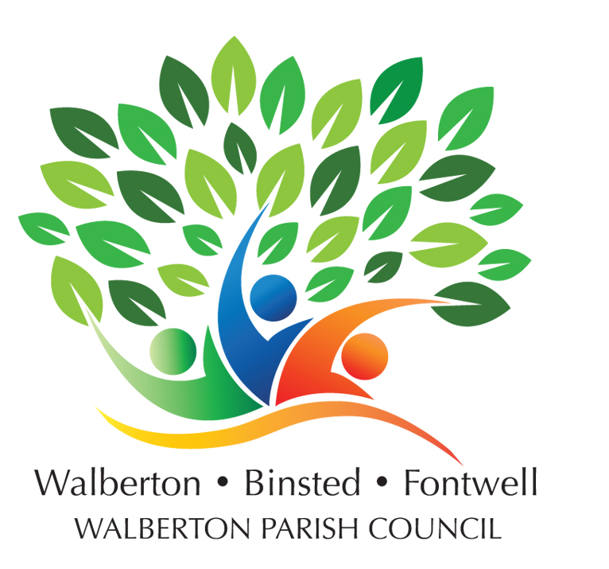

DRAFT VERSION

### **MINUTES OF THE WALBERTON ANNUAL PARISH MEETING**

### **HELD IN THE FONTWELL COMMUNITY CENTRE, FONTWELL**

### **at 1915 on Monday 21 May 2024**

### Present: Councillors Andy Vawer (Chair), Douglas McElvogue (Vice chair), Toby Hewson, Andrew Titmus, Louise Higham, Chloe Stevens (Clerk), PCSO Caroline Wilson, Arun Councillors Penycate and McAuliffe, members of the public

1. The Chair welcomed everyone to the first meeting at Fontwell
2. No apologies for absence were received
3. The minutes from the previous meeting were agreed
4. The Chair presented an overview of the Council’s activities for the past twelve months
5. Presentations were received from
   1. Richard Gooding representing the Royal British Legion – Richard thanked the volunteers who help fundraise for the Poppy Appeal each October and asked if any other people were able to help
   2. Brenda Bailey from Walberton Gardeners Club – Brenda provided an overview of the Gardeners Club’s activities and summer show.
   3. Chris Fuller from Arun Community Transport – Chris explained how Arun Community Transport can help local people in need of an affordable door-to-door taxi service for medical appointments and similar
   4. Jo Strain from ABE Creatives – Jo described the group’s activities in encouraging
   5. Gemma, clerk from Barnham & Eastergate Parish Council – Gemma discussed how their litter picking schemes work
   6. PCSO Caroline Wilson provided an update on local policing and crime and encouraged reporting so that resources could be directed to where needed most
6. Members of the public discussed litter picking and local appearance, volunteering.
7. The attendees were thanked and the meeting was closed by the Chair