Proposed Small Housing Development in Binsted Park,
Binsted Lane, BN18 0LQ

It is the intention of the owners, Mr & Mrs William Pethers, to make pre-application enquires to the Southdowns National Park Authority for a Proposal of a Change of use of agricultural land to residential use for the construction of a number of dwellings, based on net dwellings proposed in the pre-application service structure.

• Acreage of plot = 1 acre approximately.
•
• Plot location: East of Binsted lane situated in the northern corner of Binsted Park (Small Park).
•
• The number of dwellings proposed: two or three.
•
• Size of the dwellings: floor areas: 86 – 120 sq. m. maximum.
•
• All dwellings to be Affordable or Self-build.
•
• Access via Binsted Lane, North to the A27.
•
• Services: All, apart from main drainage and gas are available.
•
• Internet: Fibre to the premises (FTTP) has been started and cables laid within the Park ready for connection.

We are aware that the affordability of housing goes to the heart of the National Park's statutory duty.

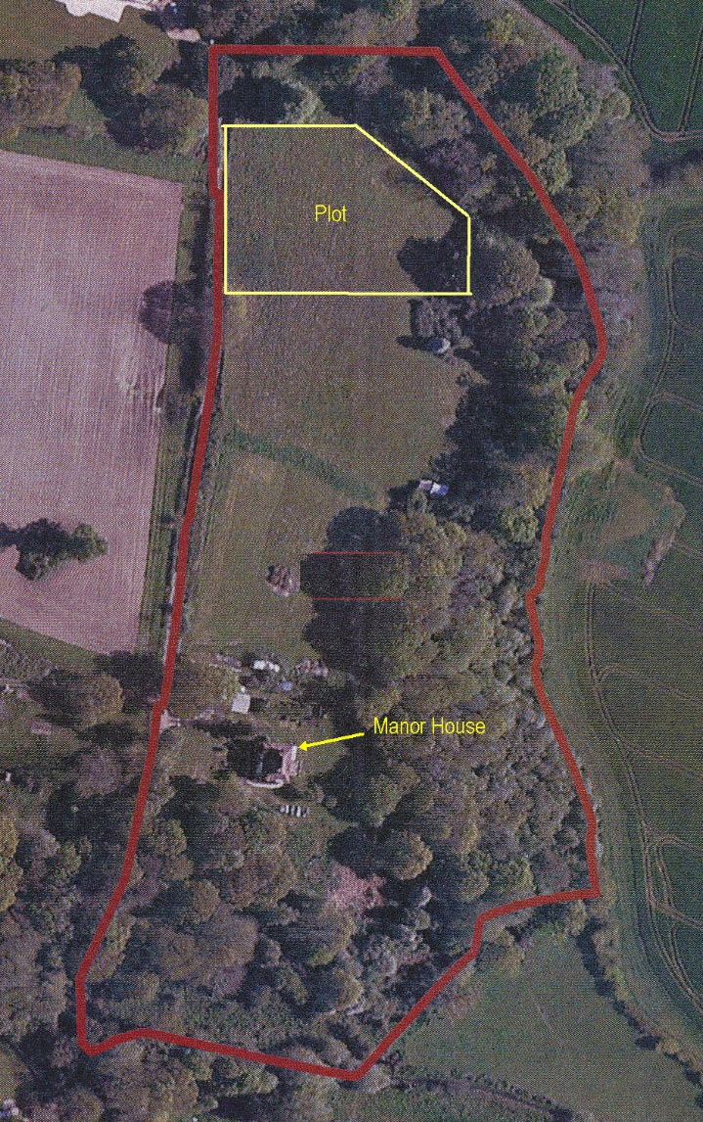
Mr & Mrs W Pethers.
Manor House, Binsted Park BN18 0LQ

Documents:
Plot location.
Other photographs of site.

South Downs Local Plan Background Papers:
Supply of Homes.
Affordable Housing.
Both papers updated April 2018.

