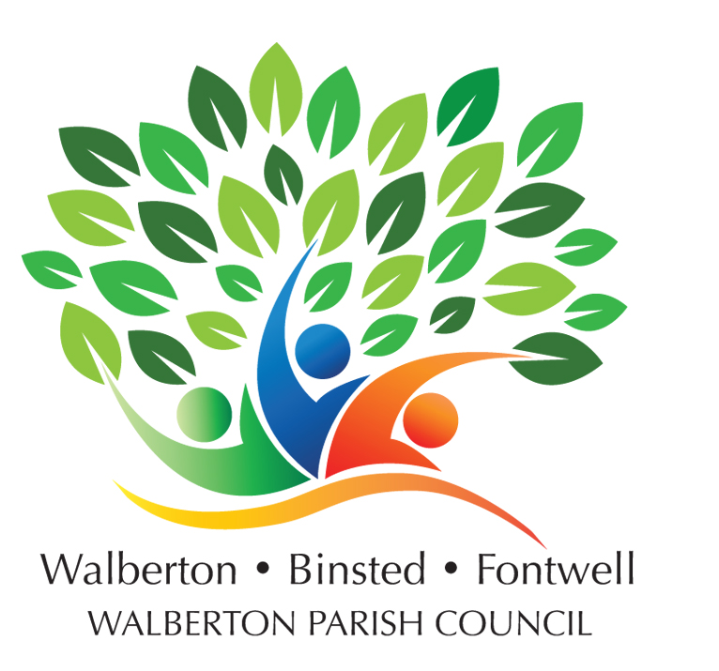
WALBERTON, BINSTED & FONTWELL
ANNUAL PARISH MEETING – 21st May 2019
PARISH COUNCIL CHAIRMAN’S REPORT

I have the dubious honour of being re-elected as Chairman of the council last week for a 4th year.

My first pleasure is to introduce you to all our parish councillors whose positions on committees will be decided at the next meeting of each.

Allan Coe – co-opted last week
Andrew Ratcliffe who joined us last July after this meeting
Andy Vawer newly elected and representing Fontwell
Bob Rogers – co-opted last week but has served for several years
Douglas McElvogue – newly elected
Keith Stevens also newly elected
Malcolm Porter – another new one
Paul Fisher new and representing Fontwell

Last, but no means least is our only paid part time employee, our clerk – Andy Peppler.

Last year was particularly challenging with so few councillors having to do double the amount of work. I’d like to thank Angela and Claire for their support before retiring. Fortunately, Claire will continue to help as a member of the highways and Tuppers working parties, Neighbourhood Plan and social media. Angela, who is responsible for our Neighbourhood News design, is also willing to continue to help.

The council has three main committees, Planning, General Purposes and Finance.
There are several others such as Staff Matters, Neighbourhood Plan, Community Resilience and working parties - Environmental and Green matters, Tuppers, Fontwell Green, Highways and the WalBinFont team organising our villages events.
A minimum of one councillor sits on each but the remaining members are people like you who want to help. If you have an interest in any specific topic and are willing to help, then please contact Andy Peppler or any councillor.
So what did we achieve last year?
This Pavilion has undergone a transformation from a drab old wooden hut to a far smarter building. Wates, the Tupper’s developer, provided help with painting the interior last June, a volunteer painting party smartened up the ladies, hallway, kitchen and touched up the main room. With the help of money from the solar farm in Yapton lane we have new flooring, curtains and exterior repairs and waterproof paint. In addition, Andy Peppler does many little handyman jobs, for which we thank him, and he handles all bookings – of which we have seen a big increase.
Flooding – we secured a grant from West Sussex Operation Watershed but are still awaiting their full evaluation of risks, particularly in Eastergate Lane.
By having a Neighbourhood Plan in place, we saw off the potential Welbeck development for 157 homes in Wandleys Lane – as you will be aware a review is under way to help us keep the big developers at bay. There have been almost 90 planning applications to review.
The Finance & Legal committee recommended this year that our grants only be given to local organisations. We distributed £3,000 to 12 and for the first time we received a thank you from every one that benefited.
We are very fortunate to have a number of local residents who help in varied ways. The Walberton Task Force keep an eye on vegetation in the car park, The Pound and Jubilee Wood. Help has been given with roof repairs, painting, selling items, hanging curtains, refurbishing furniture, dump runs, dog poo bin bags, checking defibrillators and our Neighbourhood News deliverers.
Do you care about environmental matters? We would like to recruit new members to the team – helping to keep an eye on all our trees, hedges, car park, play areas, the Pound, Pond and Village Green, bus shelters, seats and reporting what needs doing.

We want to keep our villages tidy so we have planned a Litter Picking and Painting Day for Saturday 15th June.

Will you give some time – maybe involve your children too? We have special packs to help with the litter. Painting – we will be painting the changing room outside walls and the courtyard area to match our new frontage.

Our new web site has been well received with many of you visiting it. Social media has also played a big role in keeping people abreast of what is happening in our villages.

The resident’s monthly newsletter has a high level of engagement – you don’t just read it but follow links! Are you on the email list? If not please see a councillor and sign up today.
As you know we set up the POP (Protect our Parish) fund and the money has been put to very good use and will continue to do so. The fund stands at £22,000 which will be kept to help challenge any threats to our villages.
Our WalBinFont weekend last July was another resounding success and raised £1,200 For Just Different and £4,900 for POP. We have taken a break this year, but a full weekend is planned for next year. Will you join the team – contact Keith Stevens, Allan Coe or any councillor.
You have a strong and committed Parish Council dedicated to producing what you, the people of the Parish want. They enjoy their roles, social connections and participation in events, have a true sense of purpose and most importantly, managed to have fun and a laugh.
Don’t forget all our meetings are open to the public with an opportunity to ask questions and offers of help are always welcome.
A big thank you to everyone for their voluntary service, unwavering support and hard work.

Suzanne Clark - Chairman Walberton Parish Council. 21st May 2019

