Sunny Corner development
This proposed development is for nine 3 and 4 bedroom houses on land adjacent to Sunny Corner. The land is currently an unused mowed area adjacent to the front of the house which is too large for a garden and too small to use for agriculture. The plot is surrounded by existing houses to the south, east and west and woodland to the north (the proposed development design protects the woodland).
The houses have been designed to be in character with the village and are a mix of brick, render and flint panels, with plain clay tiles and tile hanging with wooden windows and traditional porches.
The development will use an existing access onto West Walberton Lane and the houses will not be very visible from the lane.
This plot was included in the previous Neighbourhood Plan for a combination of nine low cost and retail houses. Unfortunately, the examiner removed it due to lack of evidence of the need for affordable housing.
At the same time Arun District Council (ADC) included the site in their Housing & Economic Availability Assessment and classified it as being ‘deliverable’ for 29 houses (deliverable sites are “assessed to be suitable, available and achievable”).
As a result of the allocation of the site within the HELAA we put forward a planning application to ADC. However, in consideration of the neighbouring properties in Copse Lane and West Walberton Lane and in line with the Parish’s desire for small developments we applied for nine houses rather than ADC’s suggested 29.
All the required surveys etc have been completed and any concerns raised were addressed. There are therefore no statutory planning objections (e.g. traffic, drainage, ecology) to the development. The owners were told several times during the application process that the site would be recommended for approval but after nine months ADC rejected the application. Given other developments that they have approved in the last 12-18 months their stated reasons for rejection of this development (over urbanisation, light pollution and it not being in a sustainable area) seem very odd.
An appeal against the decision was submitted in September but the process has only just started. There is no certainty that it will be successful which is why the site has been put forward for the Neighbourhood plan.
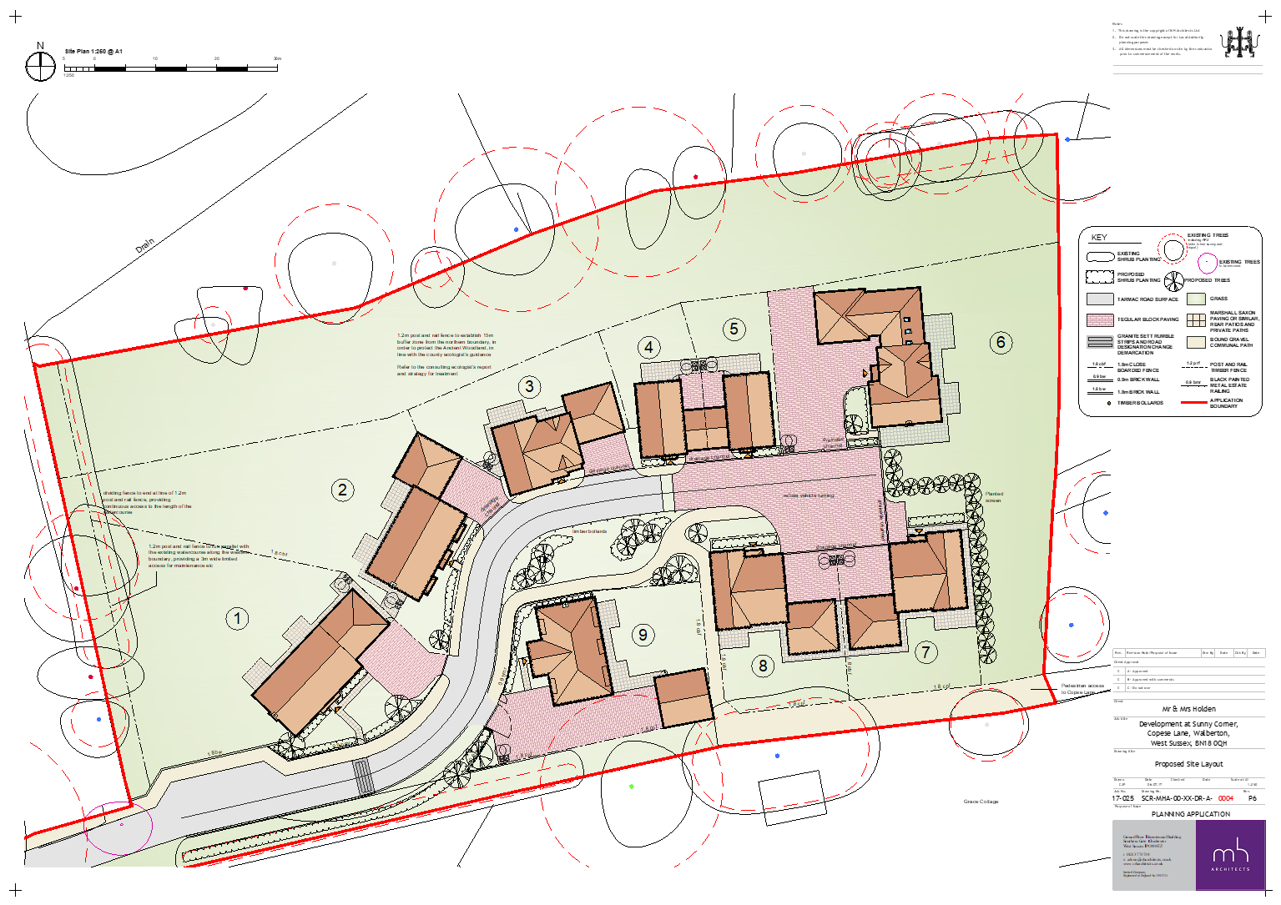
In summary, this development is in line with what the Parish have said they want i.e. small developments. It is designed sympathetically and is ready to go once approval is given. It will make good use of currently unused land and provide an attractive addition to the available family housing in Walberton.

